Acts of the Apostles
A Study of New Testament History
Lesson 18
Acts 20:1 – 21:16
Paul's Third Missionary Journey – Part 2

Introduction:
During Paul's 3-year stay in Ephesus he did much to spread the gospel throughout that region of Asia. But despite his successes there, he remained deeply concerned for the welfare of the churches he had helped to establish in Macedonia and Achaia. Therefore, Paul sent Timothy to Macedonia to encourage the brethren there, and he wrote a letter to the church in Corinth, and another to the churches of Galatia. The letter to the Corinthians was not only a scathing rebuke of the division that threatened the future of the church there, but also addressed a series of questions the brethren had sent to Paul on a wide range of troubling issues. In addition to the letter, Paul also felt it was necessary to send Titus to Corinth on a two-fold mission: first, to begin collecting money for the needy saints in Jerusalem (1Corinthians 16:1-4; 2 Corinthians 8:1-6; 12:17-18), and second, to report on how his letter to the Corinthians had been received (2 Corinthians 7:5-15).

Eager to hear from Titus, Paul departs Ephesus and travels to Troas to preach the gospel there and to meet Titus. However, when Titus did not arrive at the expected time, Paul sailed to Macedonia where he found Titus and learned the encouraging news Titus brought concerning the affairs in Corinth (2 Corinthians 2:12-13; cf. 7:5-15). While in Macedonia Paul wrote a second letter to the church in Corinth praising them for the progress they've made, and to address other concerns. From Macedonia, Paul travels to Greece where he most likely spends most of the next 3 months in Corinth before leaving due to the Jewish plot against him (Acts 20:3). While in Corinth Paul writes his letter to the church in Rome (The epistle to the Romans, ca. 58 AD).

It seems those Jews who had plotted against Paul knew of his plans to sail to Syria. Apparently they had plans to capture him as he departed. Therefore, Paul abruptly changes his plans and travels back to Macedonia where he stays for a brief time. While in Philippi, Paul is joined by Luke who stays with him there, but sends other brethren ahead to meet him in Troas (Luke once again uses the words "us" and "we"). Luke will remain with the apostle Paul from this time until his final days in Rome (Acts 28:16; 2 Timothy 4:11).

After Passover (Acts 20:6), Paul sails to Troas where he remains with the brethren there for 7 days. After meeting with the saints in Troas on the first day of the week to break bread (Acts 20:7), Paul sails to Miletus where he calls for the elders of the church in Ephesus to come meet him (Miletus is approximately 28 miles south of Ephesus by land). It is here that Paul gives the Ephesian elders his final exhortation.
After sailing to Tyre, Paul found some brethren there who warned him "through the Spirit" not to return to Jerusalem. When Paul arrived in Caesarea he stayed briefly in the home of Philip the evangelist. The warning against returning to Jerusalem was given one more time by a certain prophet named Agabus who warned the apostle that he would be bound and delivered to the Gentiles. Despite the passionate pleas of the brethren to persuade Paul against returning to Jerusalem, the apostle replied "For I am ready not only to be bound, but also to die at Jerusalem for the name of the Lord Jesus." (Acts 20:13).

Memorization:
Acts 20:7 – Now on the first day of the week, when the disciples came together to break bread, Paul, ready to depart the next day, spoke to them and continued his message until midnight.

Key Events of Acts 20-21:
- Paul returns briefly to Macedonia and Greece (Corinth)
- While in Corinth Paul writes Romans
- Paul's final exhortation to the Ephesian elders
- Meets with the brethren in Troas on the first day of the week to break bread
- Warned twice against returning to Jerusalem

Link to Online Bible Study Tools:
These websites contain numerous Bible Versions and Translations, Concordances, Dictionaries, Lexicons and many other useful tools: http://biblos.com/ and http://www.biblestudytools.com/ (Click on "Our Library" at the top of the home page)

The Exposition:
I. Paul's journey into Macedonia and Achaia (Acts 20:1-6)
A. Paul strengthens the brethren (Acts 20:1-2)
1. What was the "uproar" mentioned in Acts 20:1?

2. Where did Paul go next, and what did he do there?

3. From what we learned in the Introduction, what was one of Paul's primary reasons for going to Macedonia?

B. Paul in Greece (Acts 20:2)
1. How long did Paul spend in Greece (Corinth).

2. From what we learned in the Introduction, what letter did Paul write during this brief stay?

3. What caused Paul to leave so soon and to abruptly change his plans to sail to Syria?

4. Where did Paul go from Greece, and who were those whom he sent ahead to Troas?

5. What do we know about the following men:
a. Sopater: (Rom 16:21)

b. Aristarchus: (Acts 19:29; 27:2; Col 4:10; Philemon 24)

c. Gaius: (1 Cor 1:14; Rom 16:23; 3 John 1)

d. Tychicus: (Eph 6:21-22; Col 4:7; Titus 3:12; 2 Tim 4:12)

e. Trophimus: (Acts 21:29; 2 Tim 4:20)

6. Paul and Luke sail to Troas following what holy days?

II. Paul's return trip from Troas to Jerusalem (Acts 20:7 – 21:16)
A. Paul in Troas (Acts 20:7-12)
1. On what day of the week did the disciples come together to "break bread"?

2. The terms "break bread," "breaking bread," "breaking of bread" or "broken bread" can either refer to a common meal or to the Lord's Supper. The only way to determine how these phrases are being used is to consider them in their context. From the following examples, how are these terms being used? Explain your answer.
a. "Breaking of bread" (Luke 24:35; Acts 2:42)

b. "Breaking bread" (Acts 2:46)

c. "Break bread" (Acts 20:7)

d. "Broken bread" (Acts 20:11)

3. Judging from the context of Acts 20:7-12 what time of day did these disciples assemble on the first day of the week to "break bread"?

4. Why do you think these brethren met on the first day of the week at this time of day?

5. Who is Eutychus and what happened to him?

6. What did Paul do after restoring life to Eutychus?

B. From Troas to Miletus (Acts 20:13-16)
1. How did Paul make the 20 mile journey from Troas to Assos?

2. What did Paul do when he arrived in Assos?

3. Why did Paul decide to sail past Ephesus?

C. Paul in Miletus (Acts 20:13-38)
1. Who did Paul call for immediately after arriving at Miletus?

2. How does Paul describe his work among the Ephesians?

3. What was Paul expecting would happen to him upon returning to Jerusalem?

4. Why did Paul not fear for his life?

5. Why did Paul consider himself to "innocent of the blood of all men"?

6. If we fail to "declare… the whole counsel of God" to others what does that say about the blood of those whom we have failed to teach? (Compare: Ezek 33:7-9)

7. What limitation dose Acts 20:28 place on the jurisdiction of elders?

8. From where would false teachers arise, and what would their intentions be? Explain how this applies to us today.

9. How long had Paul worked with the church at Ephesus?

10. How did Paul provide for his needs while working with the church in Ephesus?

11. Why was Paul's departure from these elders so emotional?

D. From Miletus to Jerusalem (Acts 21:1-16)
1. How long did Paul stay in Tyre and what warning did they give?

2. When arriving in Caesarea where did Paul stay?

3. What is said about Philip's daughters? How could they use this gift without violating what Paul taught in 2 Tim 2:12? (See: 1 Cor 11:2-16)

4. Who is Agabus and what did he prophesy?

5. How did Paul comfort those who pleaded with him to not return to Jerusalem?

6. What was the attitude of those who pleaded with Paul when they saw he could not be persuaded?

7. Who journeyed with Paul to Jerusalem?

III. Paul's Third Missionary Journey – Part 2
1. Identify the cities during the last part of Paul's journey (Ephesus to Macedonia and Greece, and then to Jerusalem).

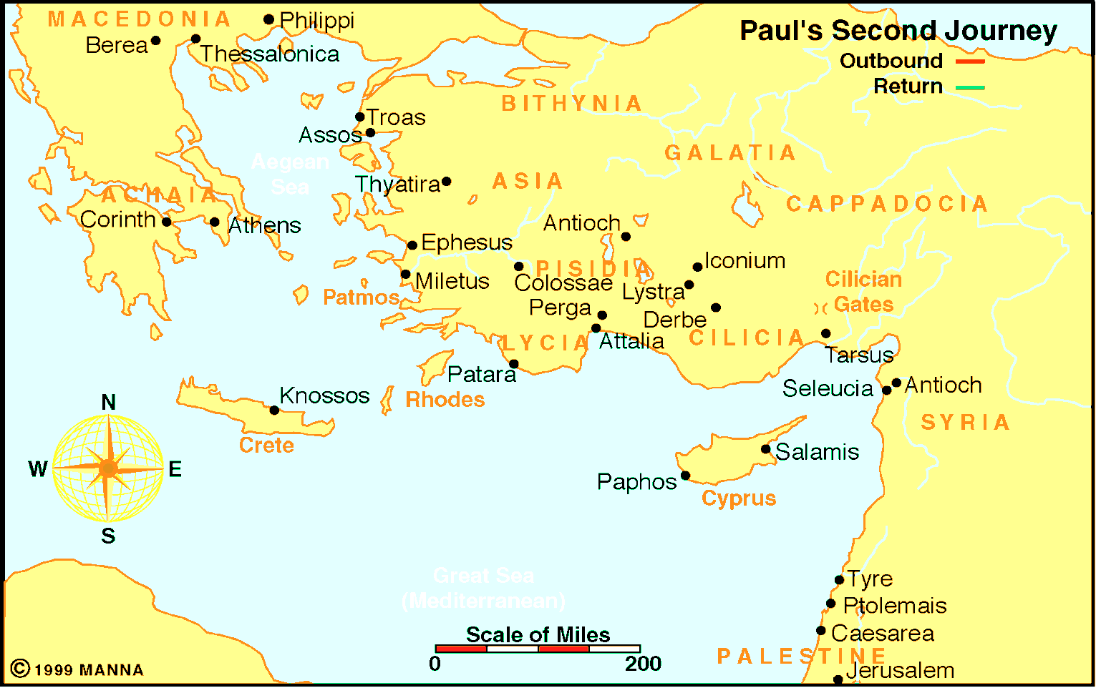
From Ephesus to Jerusalem

Application:
Be prepared to discuss what lessons can learn from these events, and how these lessons can be applied to present-day situations.

